Overall, the source codes are conducted a PC server with 64G real memory and two Nvidia GTX 3090Ti GPUs in a Windows or Linux operation system. **The implementation of the source codes requires the environment of Python 3.6.8 by the installation of Anaconda3 under the version of 4.3.30 and Pytorch under version 1.5.1+CPU and CUDA 10.2.** We install Anaconda3 under the version of 4.3.30 with Python 3.6.8 from https://repo.anaconda.com/archive/ with file Anaconda3-2019.10-Windows-x86_64.exe (https://repo.anaconda.com/archive/Anaconda3-2019.10-Windows-x86_64.exe). The documentation for the guidance, installation, and usage of Anaconda3 can be found at https://docs.anaconda.com/anaconda/. Based on Anaconda3 under the version of 4.3.30 with Python 3.6.8, we open Anaconda Prompt window and run ‘**conda install pytorch=1.5.1 torchvision torchaudio cpuonly -c pytorch**’ to install the Pytorch 1.5.1+CPU, and run ‘**conda install pytorch=1.5.1 torchvision torchaudio cudatoolkit=10.2 -c pytorch**’ to install Pytorch 1.5.1+ CUDA 10.2 (https://pytorch.org/). And the installation of Pytorch can be found at https://pytorch.org/get-started/locally/#windows-installation and the documentations of Pytorch are available at https://pytorch.org/get-started/locally/. And the tutorials of Pytorch can be seen at <https://pytorch.org/tutorials/>.

**The implementation of the source codes requires many additional python packages (e.g., scipy, numpy, matplotlib, pandas, etc.) and these packages need to be installed manually by ‘pip’ command**, leading to the inconvenience of environment installation and model implementation. To address this issue, we **employ Anaconda3** as a substitute that is a toolkit equipped with thousands of open-source packages and libraries. The documentation for the guidance, installation, and usage of Anaconda3 can be found at https://docs.anaconda.com/anaconda/. Here, we present the key steps for installing Anaconda3 with Python 3.6.8 as follows:

1. Double-click the downloaded file Anaconda3-2019.10-Windows-x86_64.exe. We get the installation interface

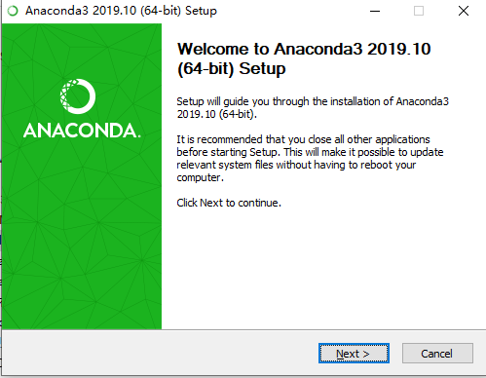

1. Click ‘Next >’ button. We have

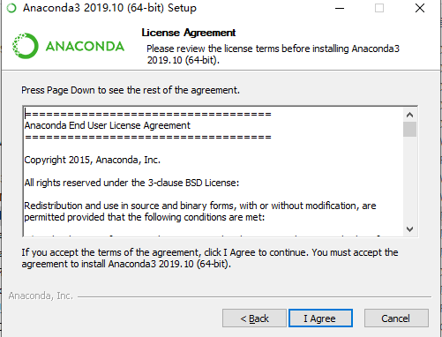

1. Click ‘I Agree’ button. We have

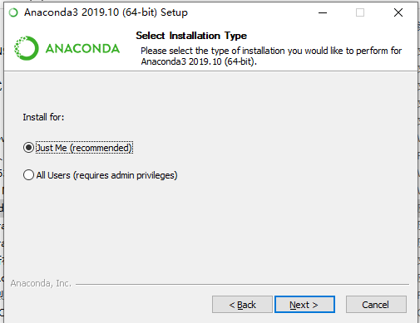

1. Choose ‘Just Me (recommended)’ and Click ‘Next >’ button. We have

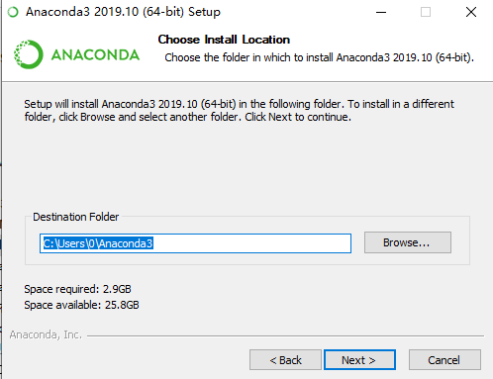

1. By selecting appropriate location for installing Anaconda3 and clicking ‘Next >’ button, we have

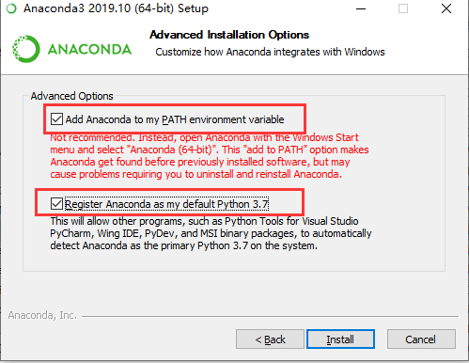

1. Tick ‘Add Anaconda to my Path environment variable’ and ‘Register Anaconda as my default Python 3.7’ and click ‘Install’. After several minutes, the Anaconda is installed.
2. Open ‘cmd’ window and input ‘conda -V’. If it outputs ‘conda 4.3.30’, then the Anaconda is successfully installed

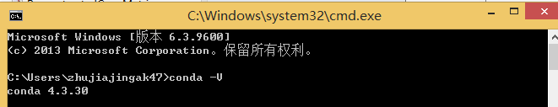

1. Open ‘cmd’ window and input ‘Python’. If it outputs the detailed information about Python 3.6.8 shown as follows, then Python 3.6.8 is successfully installed.

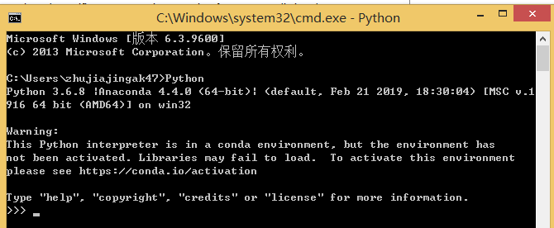

* Installation of Pytorch Framework

Based on the installed Anaconda3 with Python 3.6.8, we need to install Pytorch framework (https://pytorch.org/) under version 1.5.1+CPU and CUDA 10.2. The installation of Pytorch can be found at https://pytorch.org/get-started/locally/#windows-installation and the documentations of Pytorch are available at https://pytorch.org/get-started/locally/. And the tutorials of Pytorch can be seen at https://pytorch.org/tutorials/. Here, we present the key steps for installing Pytorch framework as follows:

1. Open Anaconda Prompt window (or cmd window) and input ‘**conda install pytorch=1.5.1 torchvision torchaudio cpuonly -c pytorch**’ to install the Pytorch 1.5.1+CPU. We have

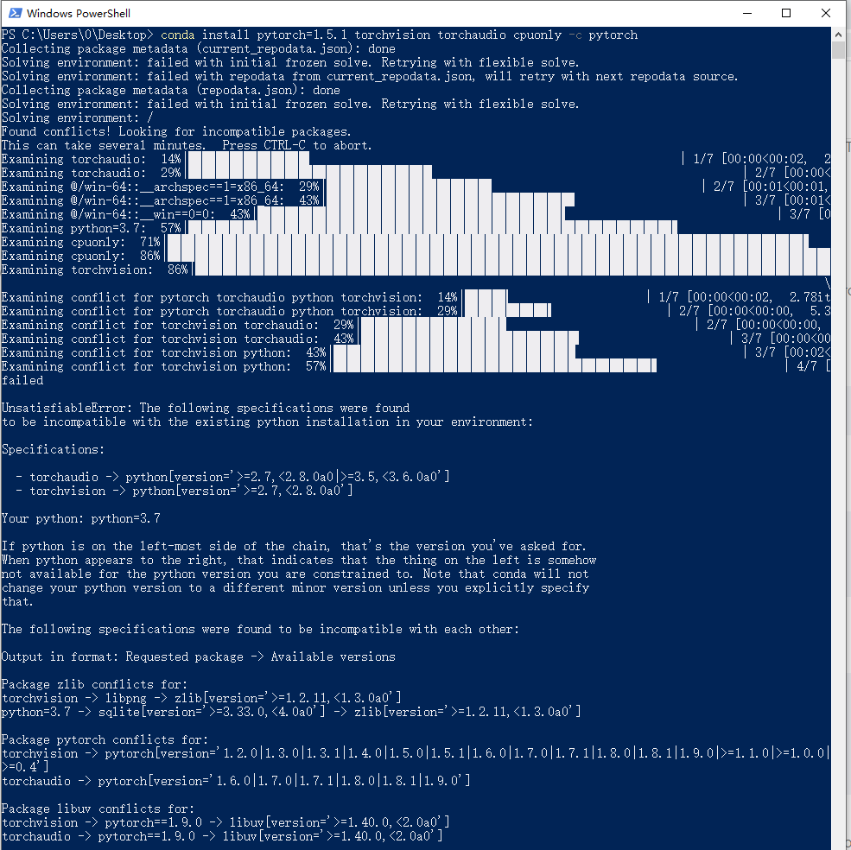

1. Open ‘cmd’ window and first input ‘Python’, and then input ‘import torch’, ‘print(torch.rand(3,3))’. If it outputs a tensor with the size of 3*3 shown as follows, then Pytorch framework is installed successfully.

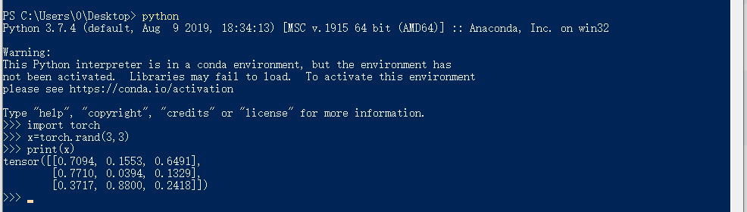

1. Open Anaconda Prompt window (or cmd window) and input ‘**conda install pytorch torchvision torchaudio cudatoolkit=10.2 -c pytorch**’ to install the Pytorch 1.5.1 with CUDA 10.2.